

COMPUTER NETWORKS

EXP 12



October 26, 2021

Roehit ranganathan

RA1911033010017 | L2

# Implementation of Network Address Translation using Packet Tracer

## Aim:

## To design a NAT (Network Address Translation) on Cisco Packet Tracer.

## Diagram:

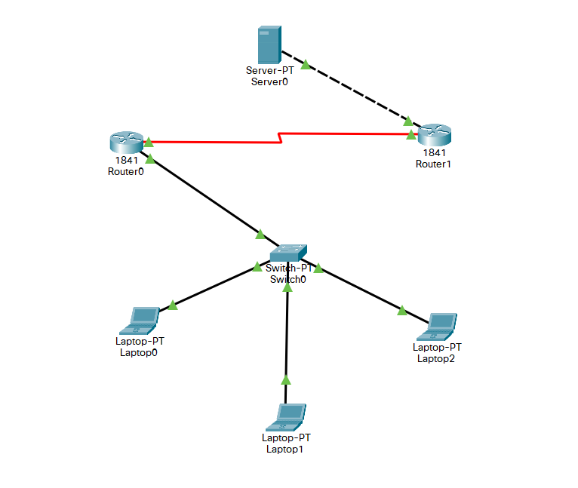

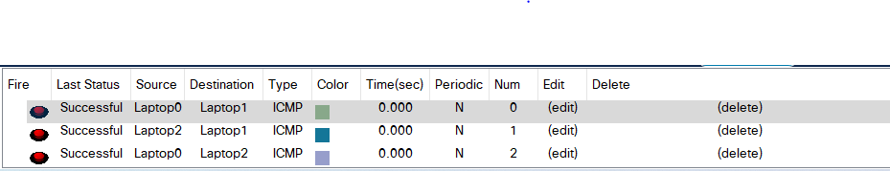

## Router 0 CLI

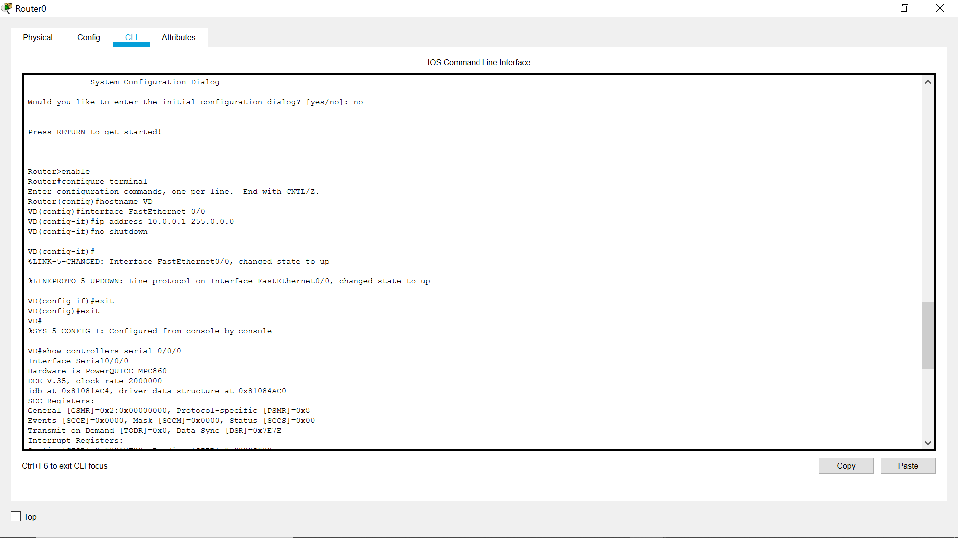

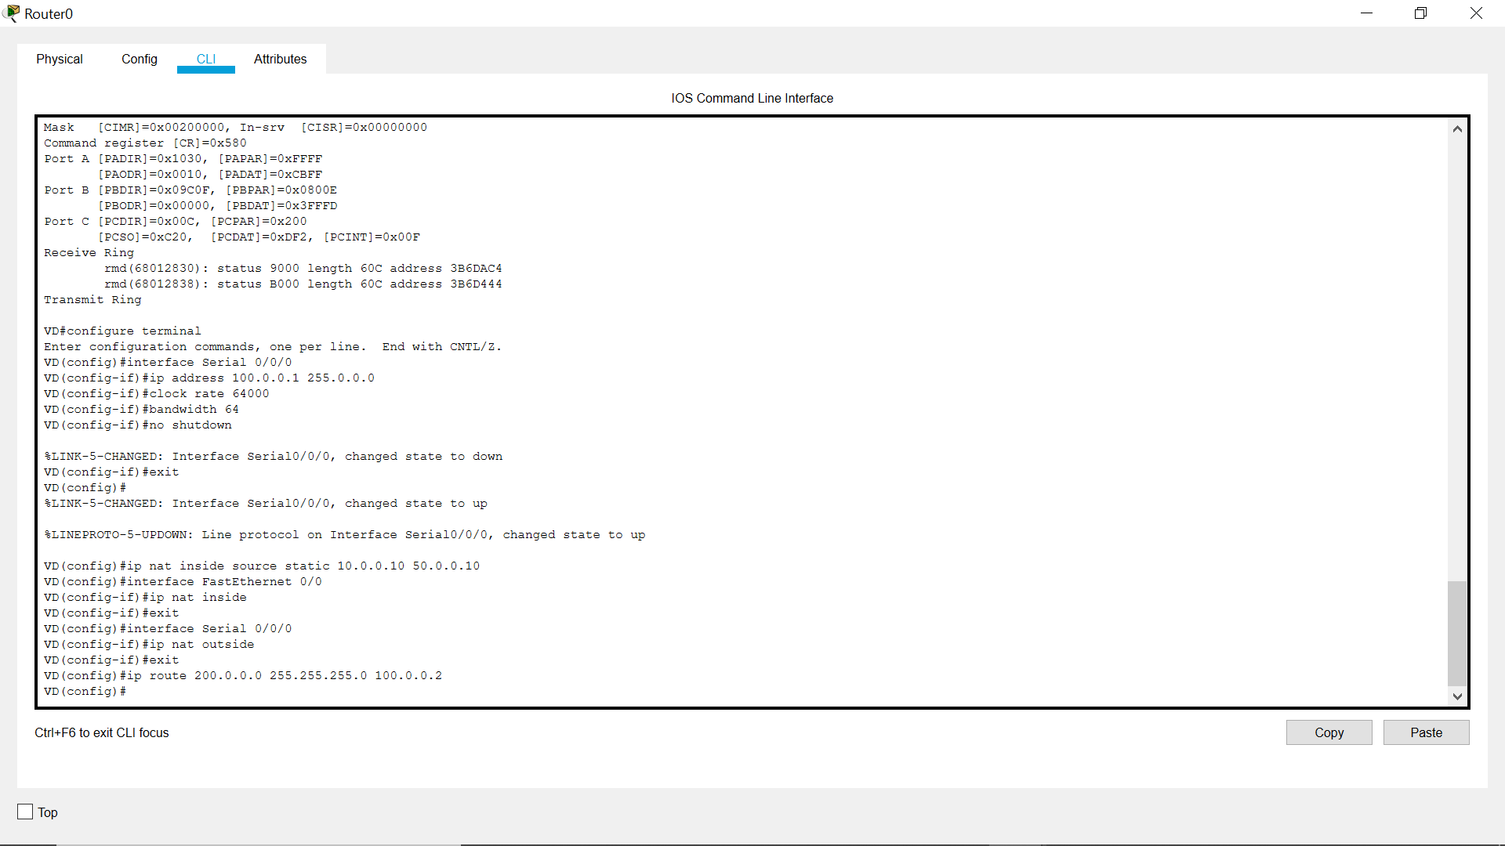

## Router 1 CLI

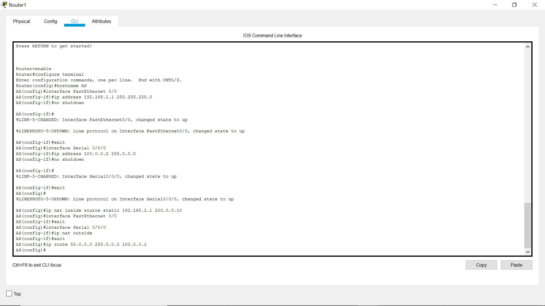

## Laptop 0 CMD

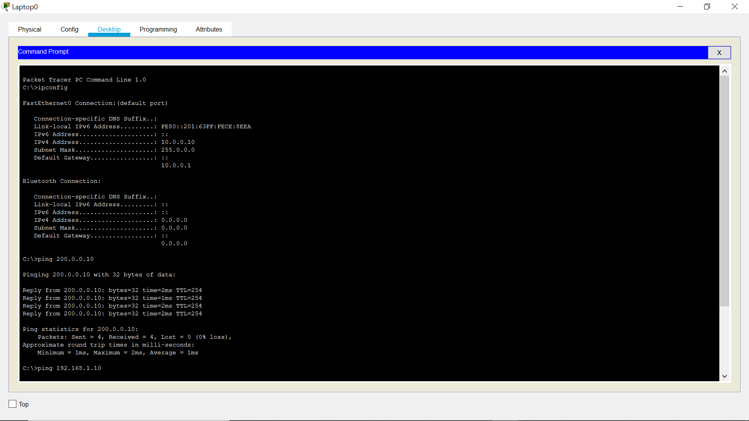

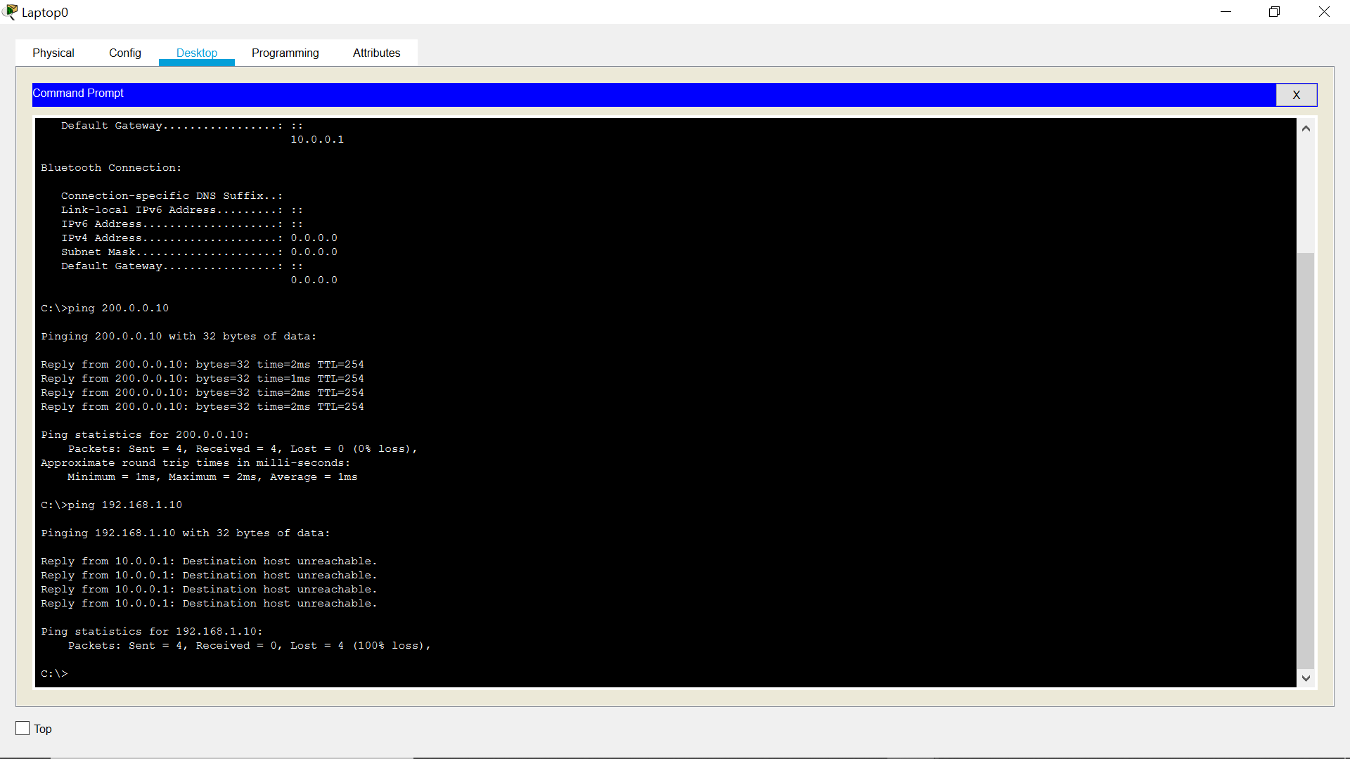

## Laptop 1 CMD

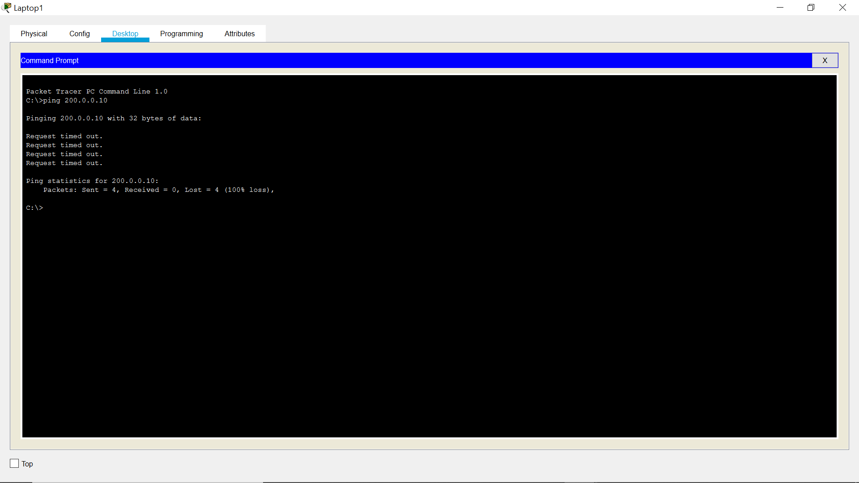

## Laptop 0 Browser

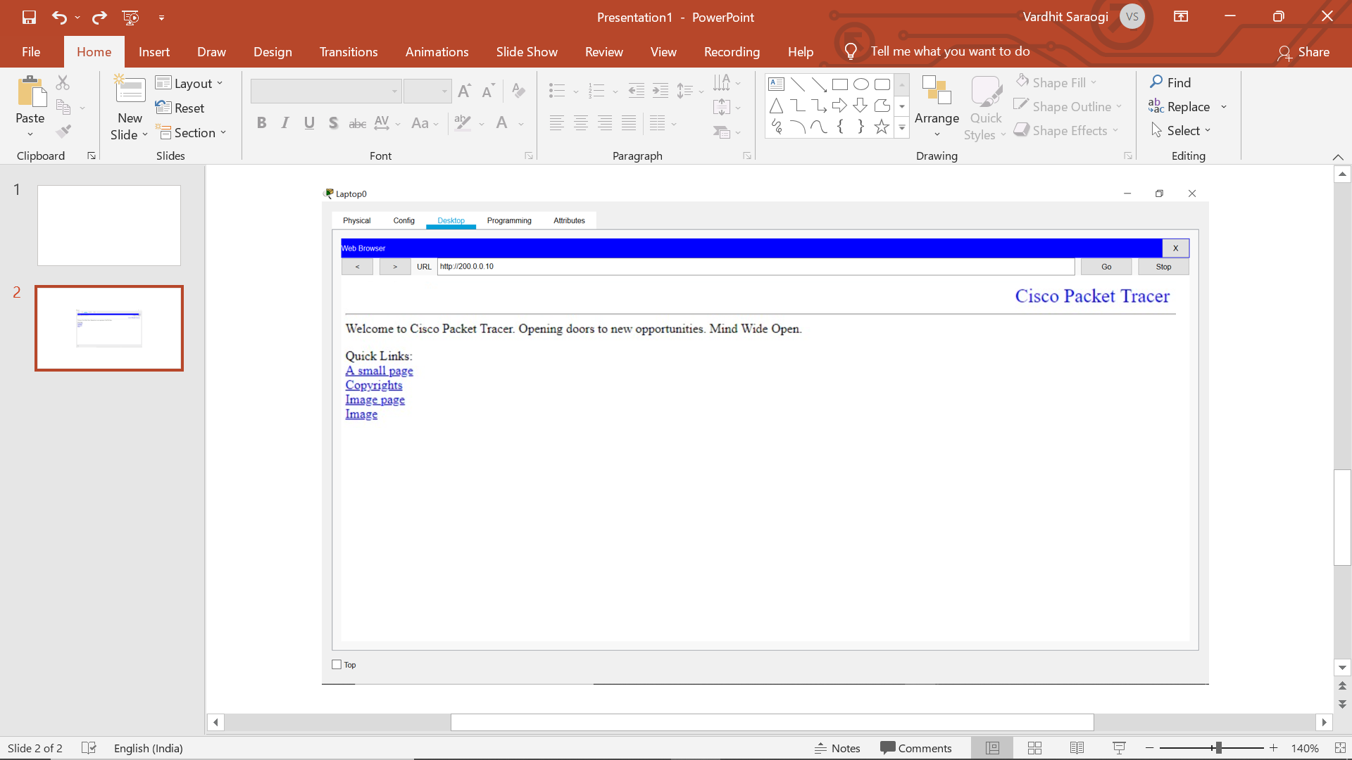

## Laptop 1 Browser

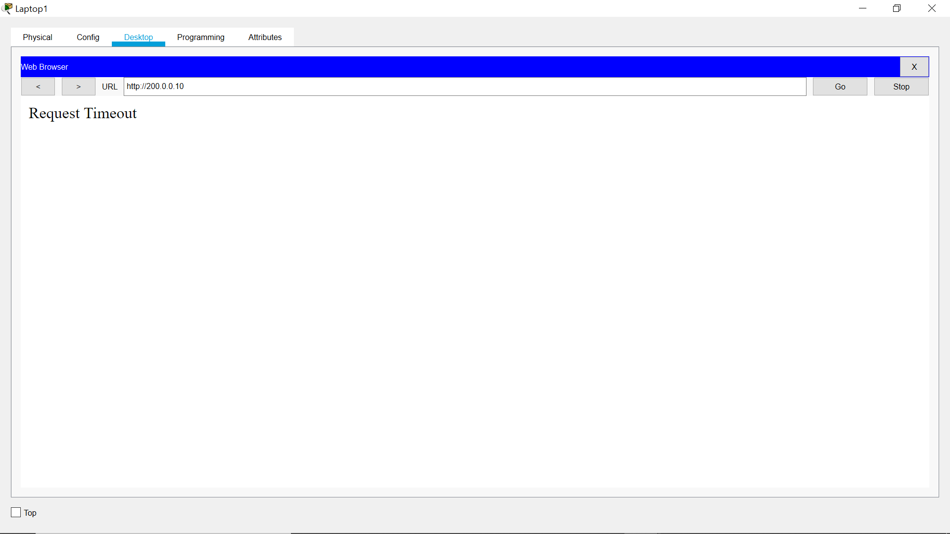

## RESULT

The above aim has been successfully achieved and verified.